ACTIVITY -1
Name : B.Hariharan Reg no :192511394

Q1: Write a C program for Array Implementation of List.
Program: #include <stdio.h> #define MAX 10
int arr[MAX]; int n = 0;
// Function to display the list void display()
{
int i;
if (n == 0)
{
printf("\nList is empty.\n"); return;
}
printf("\nList elements are: "); for (i = 0; i < n; i++)
{
printf("%d ", arr[i]);
}
printf("\n");
}
// Function to create the list

void create()
{
int i;
printf("Enter number of elements (Max %d): ", MAX); scanf("%d", Cn);
if (n > MAX)
{
printf("List size exceeded!\n"); n = MAX;
}
printf("Enter %d elements:\n", n); for (i = 0; i < n; i++)
{
scanf("%d", Carr[i]);
}
display();
}
// Function to insert an element void insert()
{
int pos, item, i; if (n == MAX)
{
printf("List is full. Insertion not possible.\n"); return;
}

printf("Enter position (1 to %d): ", n + 1); scanf("%d", Cpos);
if (pos < 1 || pos > n + 1)
{
printf("Invalid position.\n"); return;
}
printf("Enter element to insert: "); scanf("%d", Citem);
for (i = n; i >= pos; i--)
{
arr[i] = arr[i - 1];
}
arr[pos - 1] = item; n++;
printf("Element inserted successfully.\n"); display();
}
// Function to delete an element void deleteElement()
{
int pos, i; if (n == 0)
{
printf("List is empty.\n"); return;

}
printf("Enter position to delete (1 to %d): ", n); scanf("%d", Cpos);

if (pos < 1 || pos > n)
{
printf("Invalid position.\n"); return;
}
for (i = pos - 1; i < n - 1; i++)
{
arr[i] = arr[i + 1];
}
n--;
printf("Element deleted successfully.\n"); display();
}
// Function to search an element void search()
{
int key, i, found = 0; if (n == 0)
{
printf("List is empty.\n"); return;
}

printf("Enter element to search: "); scanf("%d", Ckey);
for (i = 0; i < n; i++)
{
if (arr[i] == key)
{
printf("Element found at position %d\n", i + 1); found = 1;
break;
}
}
if (found == 0)
{
printf("Element not found.\n");
}
display();
}
// Main function int main()
{
int choice; do
{
printf("\n----- ARRAY LIST MENU \n");
printf("1. Create List\n"); printf("2. Insert Element\n");

printf("3. Delete Element\n"); printf("4. Search Element\n"); printf("5. Display List\n"); printf("6. Exit\n");

printf("Enter your choice: "); scanf("%d", Cchoice); switch (choice)
{ case 1:
create(); break;
case 2:
insert(); break;
case 3:
deleteElement(); break;
case 4:
search(); break;
case 5:
display(); break;
case 6:
printf("Program terminated.\n"); break;

default:
printf("Invalid choice.\n");
}
} while (choice != 6); return 0;
}

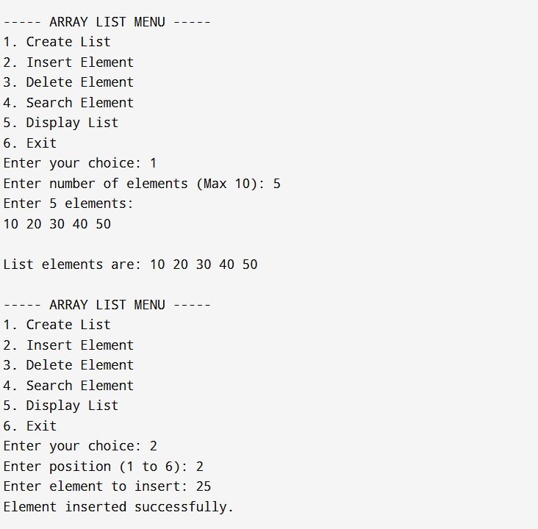
OUTPUT:

